**LIT ASSIGNMENT-DAY 15**

**NAME: CHIKATI LIKHITHA**

**EMPLOYEE ID: 46255243**

**BATCH NAME: SAP ABAP-25**

Assignment 1 – Create a Simple program to fetch data and display ALV using Std. SAP class-methods.

**STEP1**: Program to fetch data.

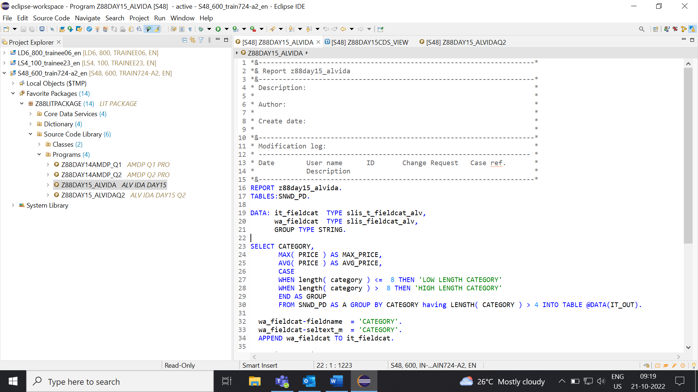

**STEP2:** Output.

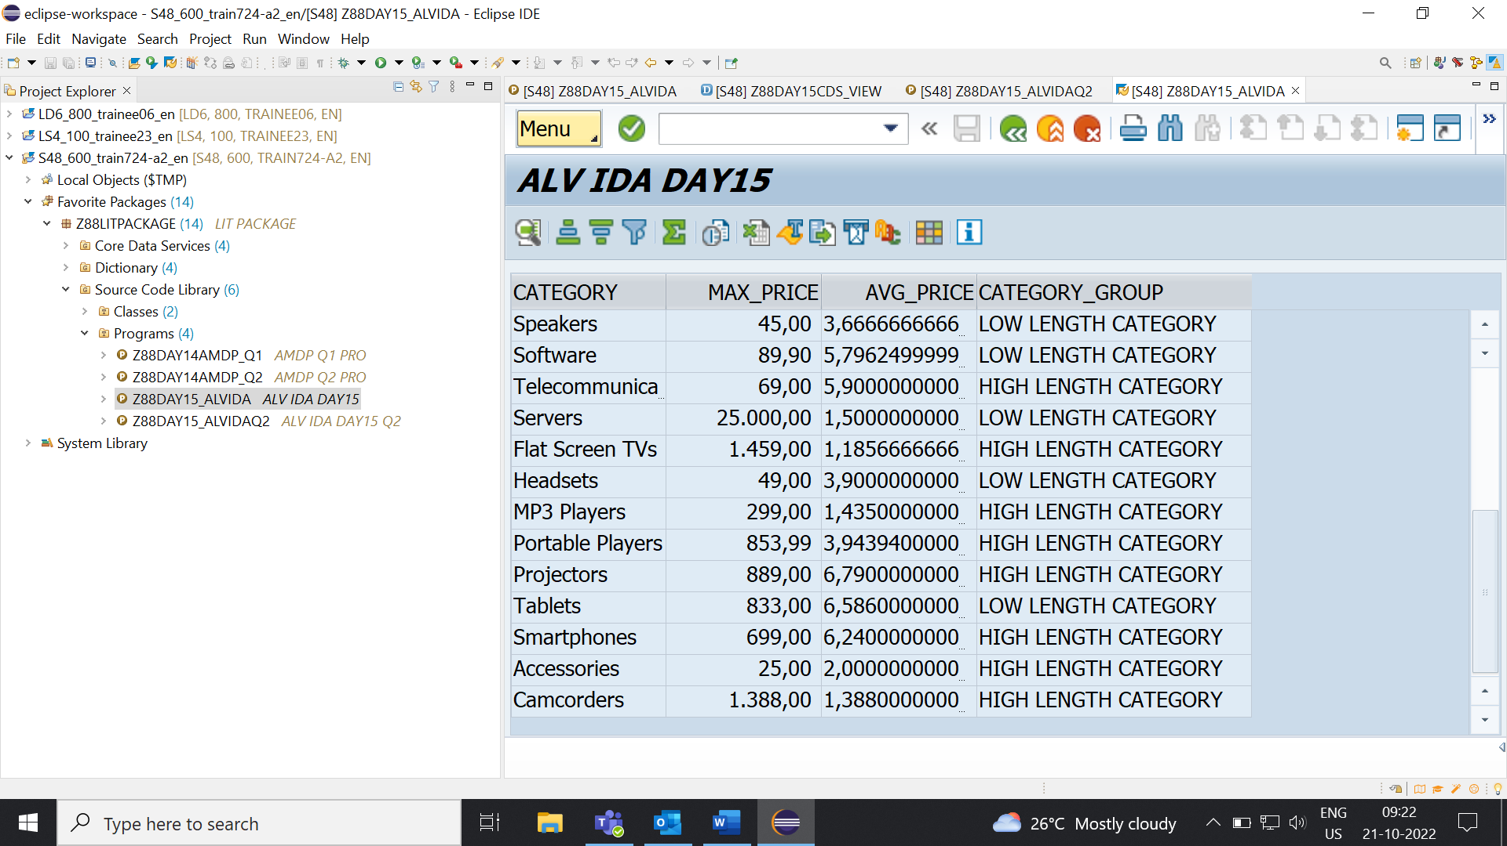

Assignment 2 – ALV with IDA.

**Scenario** –

* Create one CDS view by selecting fields VBELN,POSNR, VKORG, MATNR, MENGE from VBAK and VBAP table.
* Fetch records from CDS view in ABAP program.

**STEP1:** CDS VIEW.

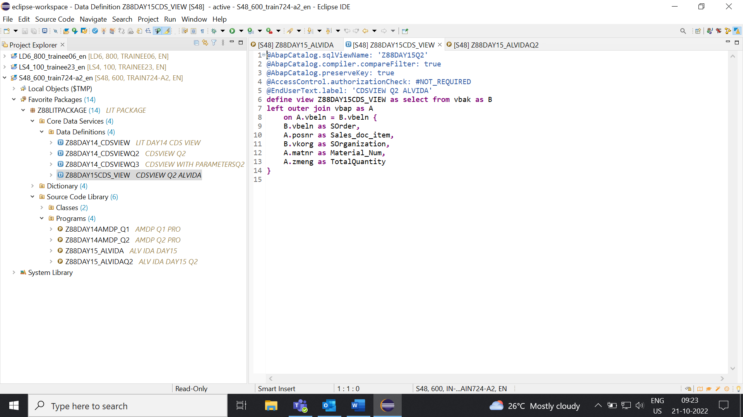

**STEP2:** Output.

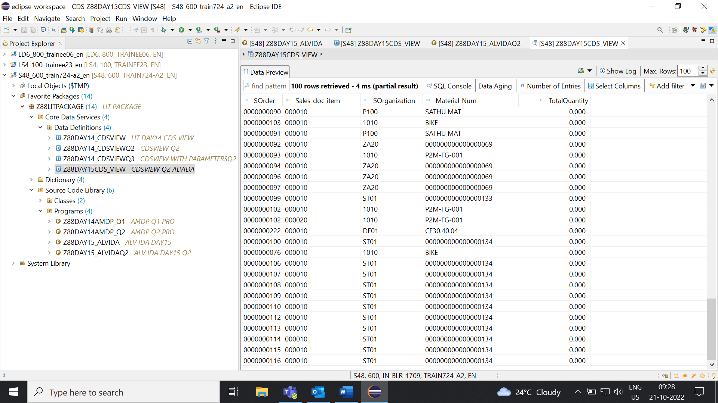

**STEP3:** Fetch records from CDS view in ABAP program.

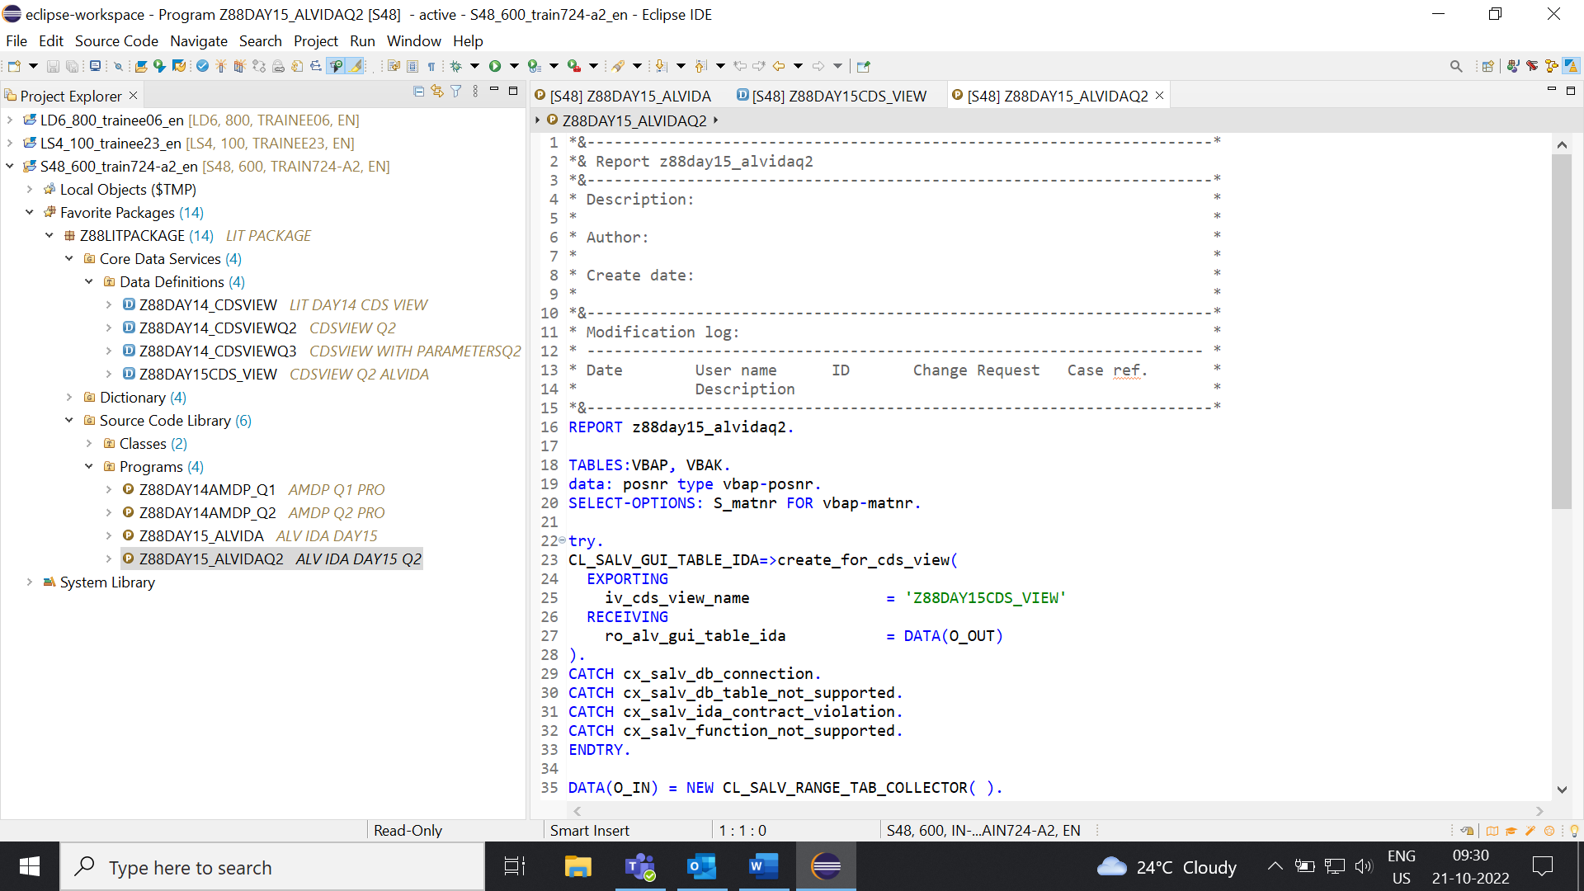

**STEP4:** Output.

